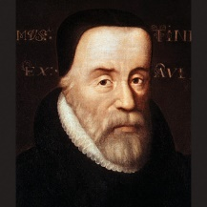 | The Tyndale Society
 | founded January 31, 1995
UK registered charity: 1020405
https://www.tyndale.org
Facebook page: “Tyndale Society”
Tyndale Society Membership brings:  - free copies of The Tyndale Society Journal  - subsidised subscription to Reformation  - free entry to events and trips  - access to resources, help, advice  - access to monthly online Tyndale Talks  - publisher discounts on selected books  - 25% discount for adverts in the Journal  - e-mail notification of events and offers | 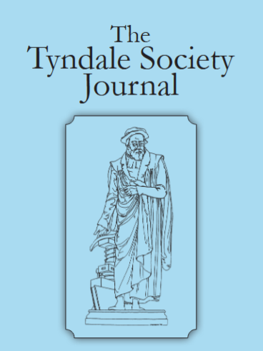 | 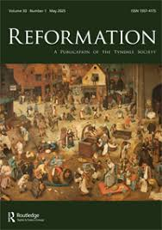
Annual membership (for Single/Couple or Organisation Membership) (tick as appropriate)
☐ Basic £22.50 / €uro 26 / US$ 45 / Can $ 60 / Aus $ 45 per year
☐ Academic £45 / €uro 52 / US$ 90 / Can $120 / Aus $90 (with subscription to Reformation)
Please set up a standing order to pay into: (using your name as the Reference)
UK Branch Sort Code: 60-70-03 (NatWest Bank), UK Account: 86110683 (The Tyndale Society)
For payments from outside the UK please quote:
BIC/SWIFT code: NWBKGB2L and IBAN: GB75NWBK60700386110683
We prefer not to handle cash or cheques – most people bank online now.
or keep this upper part and tear or cut off the lower part and hand to one us at an event,
fill this in and email this completed form to tyndalesoc@gmail.com,
or post to the Secretary, Neil Rees, 10 Tylers Hill Rd, Chesham, Bucks HP5 1XH, UK Thank you.
--------✂-------------------------------------------------------------------cut/ tear here--------------------
☐ I/ we would like to join the Tyndale Society and have paid my membership:
☐ I paid the additional amount for Academic membership to receive the Reformation journal
Title: Mr/ Miss/ Mrs / Ms / Dr / Rev / Prof / Mr & Mrs (circle those which apply)
Name(s): ……………………………………….……. Surname …………….…………………….
or
church/ college / organisation ……………………………………..………………………………………
Postal address…………………………………………………………………………………………………..
Country : UK / USA / Canada / Belgium / Netherlands / Australia / NZ /………………..……
E-mail @ddress: …………………………………………………………………………………..…………..
☐ I am a UK taxpayer (tax can be reclaimed under Gift Aid scheme for Charity No. 1020405)
☐ I am happy for my contact details to be kept on record (for UK+EU GDPR purposes)
Signature: …………………………….. Date: …………………. 2026

