 | The Tyndale Society
 | founded January 31, 1995
UK registered charity: 1020405
https://www.tyndale.org
Tyndale Society Membership brings:  - free copies of The Tyndale Society Journal  - half-price subscription to Reformation  - free entry to events and trips  - access to resources, help, advice  - access to monthly online Tyndale Talks  - publisher discounts on selected books  - 25% discount for adverts in the Journal  - e-mail notification of events and offers | 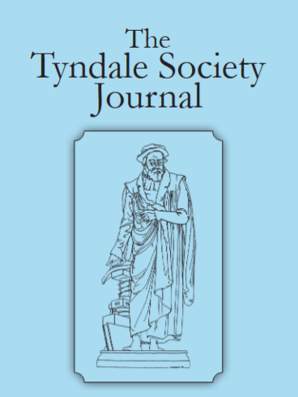 | 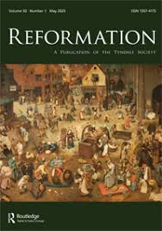
Annual membership (for Single/Couple or Organisation Membership)
£ 22.50 / €uro 26 / US$ 45 / Canada $ 60 per year
or £ 45 / €uro 52 / US$ 90 / Canada $120 (including half-price subscription to Reformation)
Please set up a standing order to pay into: (using your name as the Reference)
UK Branch Sort Code: 60-70-03 (NatWest Bank), UK Account: 86110683 (The Tyndale Society)
For payments from outside the UK please quote:
BIC/SWIFT code: NWBKGB2L and IBAN: GB75NWBK60700386110683
We prefer not to handle cash or cheques – most people bank online now.
Please fill in the part below, and email it to tyndalesoc@gmail.com, or keep this upper part and tear or cut off the lower part and hand to one us at an event.
Membership commences from the date of receipt of payment. Thank you.
--------✂-------------------------------------------------------------------cut/ tear here--------------------
☐ I/ we would like to join the Tyndale Society:
Title: Mr/ Miss/ Mrs / Ms / Dr / Rev / Prof / Mr & Mrs (circle all those which apply)
Name(s): ………………………….. Surname ………………………………….
Postal address……………………………………………………………………………………..
Country : UK / USA / Canada / Belgium / Netherlands / …….………………………
E-mail @ddress: …………………………………………………………………………………..
☐ I am a UK taxpayer (tax can be reclaimed under Gift Aid scheme for Charity No. 1020405)
☐ I am happy for my contact details to be kept on record (for UK+EU GDPR purposes)
Signature: …………………………….. Date: …………………………

